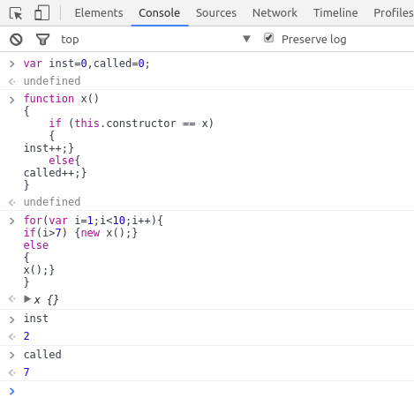
Ques1 : Create a function which returns number of invocations and number of instances of a function.

function x()
{
if (this.constructor == x)
{
inst++;}
else{
called++;}
}
undefined
for(var i=1;i<10;i++){
if(i>7) {new x();}
else
{
x();}
}

x {}
inst
2
called
7

Ques2 : Create a function which returns the copy of input object.

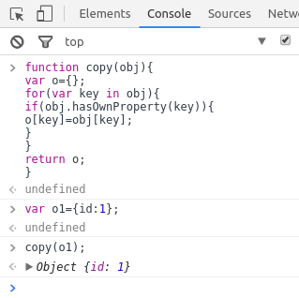
function copy(obj){
var o={};
for(var key in obj){
if(obj.hasOwnProperty(key)){
o[key]=obj[key];
}
}
return o;
}
undefined
var o1={id:1};
undefined
copy(o1);
Object {id: 1}

